Assistant Scheduler Management System

**Project Description and System Breakdown**

**Amirhossein Fakari**

# 1. Title of the System

* Assistant Scheduler Management System

# 2. System Description

The system's purpose is to make scheduling, managing conflicts and providing services easier for assistants.

* A customer management system designed to assist in managing busy timetables for service providers (Consultants) and clients (students). The system allows for room allocation, schedule conflict detection, and user notifications.
* The system supports core functionalities such as user and provider management, room bookings, and sends out reminders or conflict alerts.

# 3. Internal and External Objects in the System

* Internal Objects: Users, Service Providers, Rooms
* External Objects: Email Service (for notifications), GNATT charts, SQLite database
* Relationship: Users book appointments with Providers in Rooms, and the system detects conflicts or issues in scheduling. Email notifications are triggered for all users and clients.

# 4. System's Main Activities

Main Activities include:

1. Schedule management (booking rooms, checking provider availability)
2. User management (CRUD operations on users and providers)
3. Conflict detection and resolution in time management
4. Sending email notifications
5. Reporting dashboard via charts

# 5. Relationship between Objects and Activities

* Users: Interact with the system by booking services (through Providers).
* Providers: Linked to both users and rooms, managing their own schedules.
* Rooms: Allocated to a Provider for specific services, and linked to User bookings.
* Activities: Booking and conflict detection are directly related to these core entities.

Simplified ER

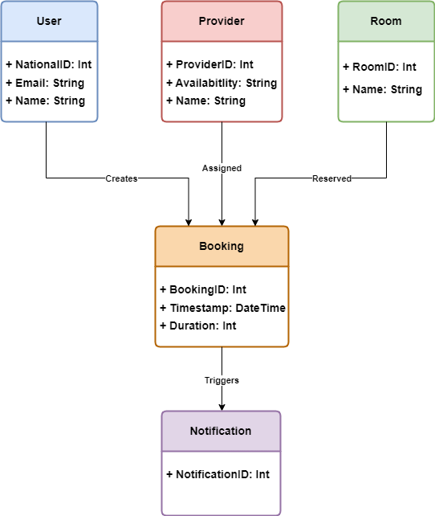

# 6. Relationship Between Internal and External Activities

* Internal Activities: Scheduling, booking management, conflict detection, CRUD operations.
* External Activities: Email notifications, graphical GNATT charts for visualizing provider schedules.

# 7. Flow of Execution/Input and Output of Data

* Input: Assistant selects a service and a provider for the specific user and chooses a time slot.
* Process: System checks room availability, validates time conflicts.
* Output: Confirm booking or suggest alternative slots, send confirmation email.

# 8. System Rules

* No double booking allowed for a provider or room at the same time.
* All users must be authenticated to access the system.
* Users can only see available time slots and not others' bookings.
* Time conflicts should trigger email notifications.

# 9. Notes

• Email Notification systems can be used to remind bookings and also be used as notifications.  
• Database is going to be a lightweight `Sqlite3` instance.  
• Graphical charts and Dashboards will be used for better management.  
• The system yet doesn't support external file imports (such as .xlsx format).  
• The only way to interact with the system is through the said windows form.